LAB 10 & 11

**MIDHA TAHIR**

**FESE-087**

**SECTION B**

**Program 2:**

This simple application demonstrates How to Use DataGridView control to display data:

1. Open a new form and place DataGrid Control and a Button on your form.
2. As in previous example import Oledb namespace and declare Connection, Data Adapter and Data Set as global variables.
3. Go to Load Event of your for and enter the following coding:

string constr = "Provider=Microsoft.Jet.Oledb.4.0; Data source =e:/std.mdb";

OleDbConnection con = new OleDbConnection(constr);

string strsql = "select * from student";

OleDbDataAdapter adap = new OleDbDataAdapter(strsql, con);

DataSet d1 = new DataSet("student");

con.Open();

adap.Fill(d1, "student");

dataGrid1.DataSource = d1;

1. Save and execute your work.

**CODING:**

using System.Data.OleDb;

namespace labtask2

{

public partial class Form1 : Form

{

public Form1()

{

InitializeComponent();

}

private void Form1_Load(object sender, EventArgs e)

{

string constr = "Provider=Microsoft.ACE.OLEDB.12.0;Data Source=C://db for c.accdb;";

OleDbConnection con = new OleDbConnection(constr);

string strsql = "select * from student";

OleDbDataAdapter adap = new OleDbDataAdapter(strsql, con);

DataSet d1 = new DataSet("student");

con.Open();

adap.Fill(d1, "student");

dataGrid1.DataSource = d1;

con.Close(); }

} }

**FORM OUTPUT:**

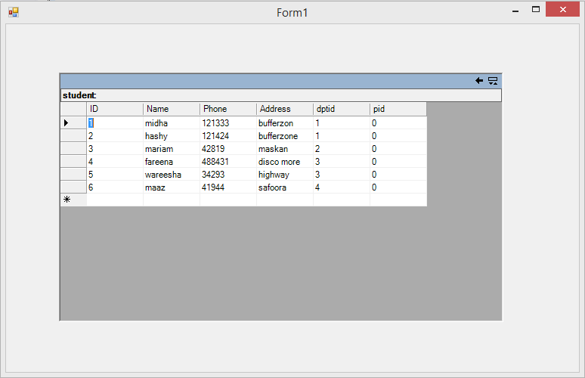

**TASK 3:**

Enhance your form according to snapshot:( Data Manipulation )

**CODING:**

using System.Data.OleDb;

namespace task3

{

public partial class Form1 : Form

{

OleDbConnection con = new OleDbConnection("Provider=Microsoft.ACE.OLEDB.12.0;Data Source=C://Users//Midha-Pc//Documents//db for c.accdb;");

OleDbDataAdapter adap = new OleDbDataAdapter("select * from student", "Provider=Microsoft.ACE.OLEDB.12.0;Data Source=C://Users//Midha-Pc//Documents//db for c.accdb;");

DataSet d1 = new DataSet("student");

int counter = 0;

public Form1()

{

InitializeComponent();

adap.Fill(d1);

}

private void Form1_Load(object sender, EventArgs e)

{

con.open();

}

private void button1_Click(object sender, EventArgs e)

{

con.Open();

//to display in text boxes

try

{

textBox1.Text = d1.Tables[0].Rows[0]["ID"].ToString();

textBox2.Text = d1.Tables[0].Rows[0]["Name"].ToString();

textBox3.Text = d1.Tables[0].Rows[0]["Phone"].ToString();

textBox4.Text = d1.Tables[0].Rows[0]["Address"].ToString();

textBox5.Text = d1.Tables[0].Rows[0]["dptid"].ToString();

}

catch(Exception ex)

{

MessageBox.Show("Error" + ex);

}

con.Close();

}

private void button2_Click(object sender, EventArgs e)

{

con.Open();

//to first

if (counter > 0)

{

counter = 0;

textBox1.Text = d1.Tables[0].Rows[counter]["ID"].ToString();

textBox2.Text = d1.Tables[0].Rows[counter]["Name"].ToString();

textBox3.Text = d1.Tables[0].Rows[counter]["Phone"].ToString();

textBox4.Text = d1.Tables[0].Rows[counter]["Address"].ToString();

textBox5.Text = d1.Tables[0].Rows[counter]["dptid"].ToString();

}

con.Close();

}

private void button3_Click(object sender, EventArgs e)

{

con.Open();

//to previous

if (counter > 0)

{

counter = counter - 1;

textBox1.Text = d1.Tables[0].Rows[counter]["ID"].ToString();

textBox2.Text = d1.Tables[0].Rows[counter]["Name"].ToString();

textBox3.Text = d1.Tables[0].Rows[counter]["Phone"].ToString();

textBox4.Text = d1.Tables[0].Rows[counter]["Address"].ToString();

textBox5.Text = d1.Tables[0].Rows[counter]["dptid"].ToString();

}

else

{

MessageBox.Show("You are already on the first record");

}

con.Close();

}

private void button4_Click(object sender, EventArgs e)

{

con.Open();

//Last

if (counter < d1.Tables[0].Rows.Count - 1)

{

counter = d1.Tables[0].Rows.Count - 1;

textBox1.Text = d1.Tables[0].Rows[counter]["ID"].ToString();

textBox2.Text = d1.Tables[0].Rows[counter]["Name"].ToString();

textBox3.Text = d1.Tables[0].Rows[counter]["Phone"].ToString();

textBox4.Text = d1.Tables[0].Rows[counter]["Address"].ToString();

textBox5.Text = d1.Tables[0].Rows[counter]["dptid"].ToString();

}

con.Close();

}

private void button5_Click(object sender, EventArgs e)

{

//Next

con.Open();

if (counter < d1.Tables[0].Rows.Count - 1)

{

counter = counter + 1;

textBox1.Text = d1.Tables[0].Rows[counter]["ID"].ToString();

textBox2.Text = d1.Tables[0].Rows[counter]["Name"].ToString();

textBox3.Text = d1.Tables[0].Rows[counter]["Phone"].ToString();

textBox4.Text = d1.Tables[0].Rows[counter]["Address"].ToString();

textBox5.Text = d1.Tables[0].Rows[counter]["dptid"].ToString();

}

else

{

MessageBox.Show("You are on the last record");

}

con.Close();

}

private void button7_Click(object sender, EventArgs e)

{

try

{

con.Open();

OleDbCommand command = new OleDbCommand();

command.Connection = con;

command.CommandText = "Delete from student where ID= "+textBox1.Text+"";

command.ExecuteNonQuery();

MessageBox.Show("Your record is deleted");

}

catch (Exception ex)

{

MessageBox.Show("Error" + ex);

}

con.Close();

}

private void button8_Click(object sender, EventArgs e)

{

try

{

con.Open();

OleDbCommand command = new OleDbCommand();

command.Connection = con;

command.CommandText = "update student set Address = 'Lahore' where ID="+textBox1.Text+"";

command.ExecuteNonQuery();

MessageBox.Show("Your record is updated");

con.Close();

}

catch (Exception ex)

{

MessageBox.Show("Error" + ex);

}

}

private void button9_Click(object sender, EventArgs e)

{

Form2 f2 = new Form2();

this.Hide();

f2.Show();

}

private void button10_Click(object sender, EventArgs e)

{

Form3 f3 = new Form3();

this.Hide();

f3.Show();

}

private void button11_Click(object sender, EventArgs e)

{

Form4 f4 = new Form4();

this.Hide();

f4.Show();

}

private void button6_Click(object sender, EventArgs e)

{//button insert

con.Open();

OleDbCommand command = new OleDbCommand();

command.Connection = con;

command.CommandText = "insert into student(ID,Name,Phone,Address,dptid) values("+textBox1.Text+",'"+textBox2.Text+"',"+textBox3.Text+",'"+textBox4.Text+"',"+textBox5.Text+")";

command.ExecuteNonQuery();

MessageBox.Show("New record has been inserted");

con.Close();

}

private void button12_Click(object sender, EventArgs e)

{ //button join

try

{

con.Open();

OleDbDataAdapter adap1 = new OleDbDataAdapter("Select student.ID , dept.dptid from student inner join dept on dept.dptid=student.dptid ", con);

DataSet d2 = new DataSet();

adap1.Fill(d2, "student");

dataGrid1.DataSource = d2;

OleDbDataAdapter adap2 = new OleDbDataAdapter("select courses.cname,emp.empname from emp inner join courses on emp.empno=courses.empno", con);

adap2.Fill(d2, "emp");

dataGrid2.DataSource = d2;

con.Close();

}

catch (Exception ex)

{

MessageBox.Show("Error" + ex); }

}

private void button13_Click(object sender, EventArgs e)

{ //to display in datagrid

con.Open();

dataGrid1.DataSource = d1;

con.Close();

}

}

}

**FORM OUTPUT:**

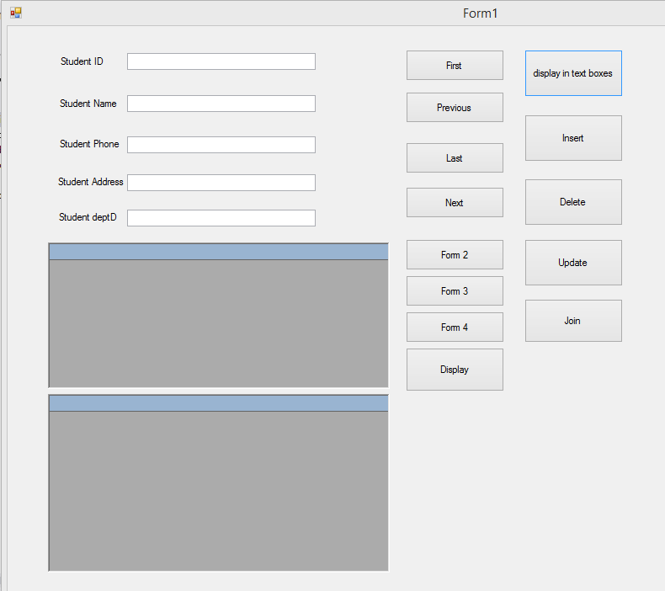

**DISPLAY IN TEXT BOXES BUTTON:**

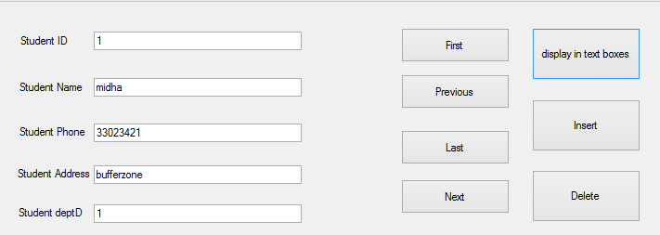

**FIRST BUTTON:**

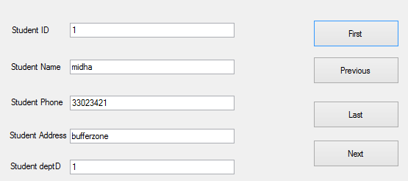

**PREVIOUS BUTTON:**

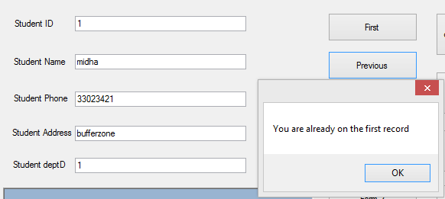

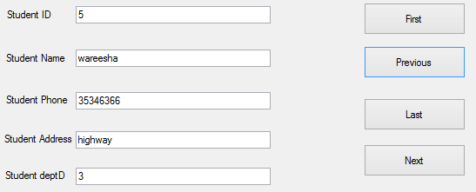

**LAST BUTTON:**

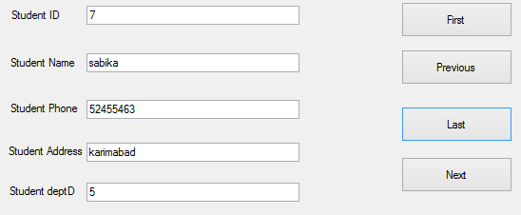

**NEXT BUTTON:**

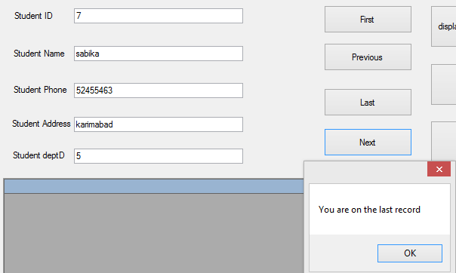

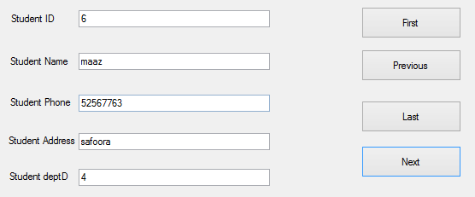

**INSERT BUTTON:**

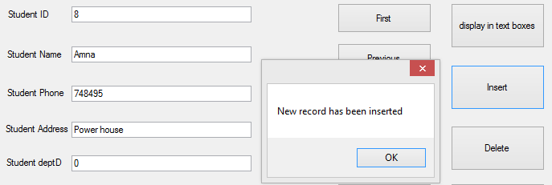

**DELETE BUTTON:**

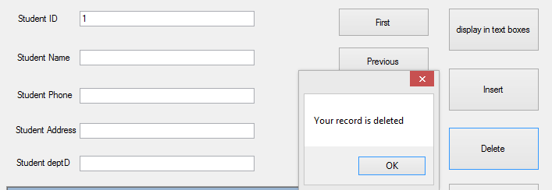

**UPDATE BUTTON:**

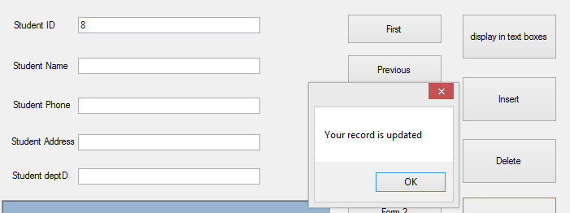

**DATABASE AFTER CHANGES:**

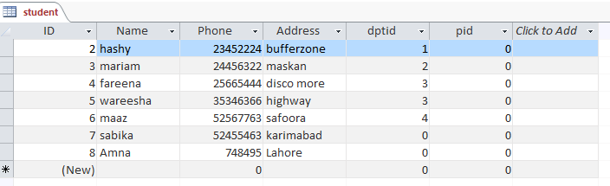

**DISPLAY BUTTON:**

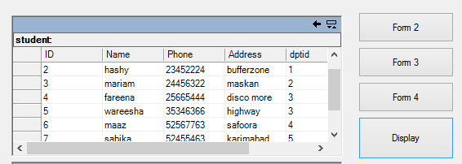

**JOIN BUTTON:**

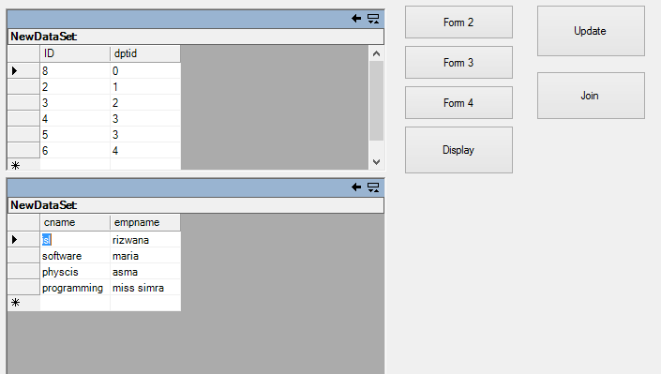

**TASK:**

**CODING:**

using System.Data.OleDb;

namespace task3

{

public partial class Form2 : Form

{

OleDbConnection con = new OleDbConnection("Provider=Microsoft.ACE.OLEDB.12.0;Data Source=C://Users//Midha-Pc//Documents//db for c.accdb;");

public Form2()

{

InitializeComponent();

}

private void Form2_Load(object sender, EventArgs e)

{

try

{

con.Open();

OleDbCommand command = new OleDbCommand();

command.Connection = con;

command.CommandText = "select * from student";

OleDbDataReader reader = command.ExecuteReader();

while (reader.Read())

{

comboBox1.Items.Add(reader["Name"].ToString();

}

con.Close();

}

catch (Exception ex)

{

MessageBox.Show("Error" + ex);

}

}

private void button1_Click(object sender, EventArgs e)

{

try

{

con.Open();

OleDbCommand command = new OleDbCommand();

command.Connection = con;

command.CommandText = "select * from student where Name='" + comboBox1.Text + "'";

OleDbDataAdapter adap = new OleDbDataAdapter(command);

DataSet d1 = new DataSet("student");

adap.Fill(d1);

dataGrid1.DataSource = d1;

con.Close();

}

catch (Exception ex)

{

MessageBox.Show("Error" + ex);

}

}

private void button2_Click(object sender, EventArgs e)

{

try

{

con.Open();

OleDbCommand command = new OleDbCommand();

command.Connection = con;

command.CommandText = "Delete from student where Name='" + comboBox1.Text + "'";

command.ExecuteNonQuery();

MessageBox.Show("Your record is deleted");

}

catch (Exception ex)

{

MessageBox.Show("Error" + ex);

}

con.Close();

}

}

}

**SUBMIT BUTTON:**

After choosing names from combo box enter submit button and the following data will be shown in datagrid.

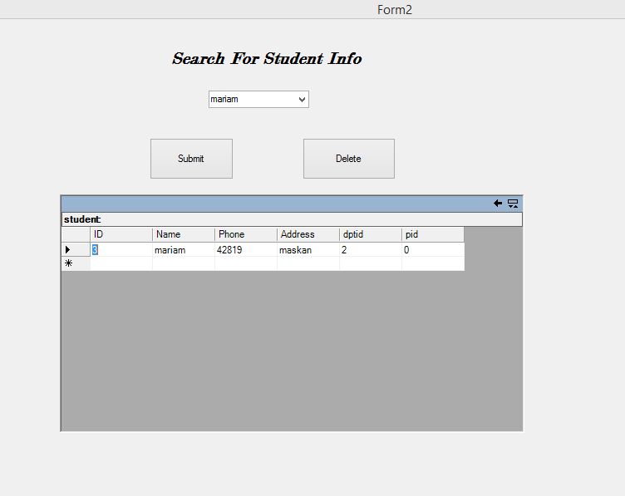

**DELETE BUTTON:**

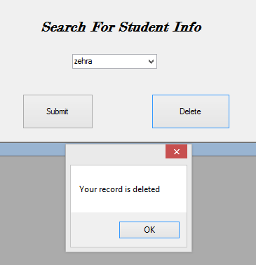

**AFTER DELETING RECORD:**

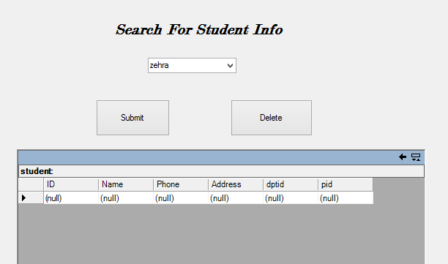

**TASK :**

**CODING:**

private void Form3_Load(object sender, EventArgs e)

{

try

{

con.Open();

OleDbCommand command = new OleDbCommand();

command.Connection = con;

command.CommandText = "select * from emp";

OleDbDataReader reader = command.ExecuteReader();

while(reader.Read()){

comboBox1.Items.Add(reader["empname"].ToString());

}

}

catch (Exception ex) {

MessageBox.Show("Error" + ex);

}

con.Close();

}

private void comboBox1_SelectedIndexChanged(object sender, EventArgs e)

{

try

{

con.Open();

OleDbCommand command = new OleDbCommand();

command.Connection = con;

command.CommandText = "select courses.cname,emp.empname from courses inner join emp on courses.empno = emp.empno where empname = '"+comboBox1.Text+"'";

OleDbDataAdapter adap = new OleDbDataAdapter(command);

DataSet d1 = new DataSet("courses");

adap.Fill(d1);

dataGrid1.DataSource = d1;

con.Close();

}

catch (Exception ex)

{

MessageBox.Show("Error" + ex);

}

**FORM:**

